

**2022**

Historical Monuments

|  |  |  |
| --- | --- | --- |
| Supervisor | Muhammad Waqas | |
| Batch | **PR2-202203E** | |
| Group | **B** | |
| Serial No. | **Enrollment Number** | **Student’s Name** |
| 1. | Student1368621 | Muhammad Waqas |
| 2. | Student1372813 | Muhammad Ahmed |
| 3. | Student1371368 | Wajid Ali |

**Table of Contents**

CERTIFICATE OF COMPLETION 2

ACKNOWLEDGEMENT Error! Bookmark not defined.3

PROJECT SYNOPSIS 4

PROBLEM STATEMENT 5

FUNCTIONAL REQUIREMENT 5

HARDWARE AND SOFTWARE REQUIREMENTS 6

FLOW DIAGRAM 7

USER GUIDE 8

**\*** HOMEPAGE (landing Page) 8

**\*** GALLERY 9

**\*** NAVBAR DROPDOWN 10

**\*** ABOUT US 11

**\*** CONTACT US 12

**\*** FEEDBACK FORM 13

**\*** MONUMENTS IN NORTH 14

**\*** FOOTER 15

DEVELOPER’S GUIDE 16

HOME 16

GALLERY OF SEVEN 17

MONUMENTS LIST 18

TASK SHEET----------------------------------------------------------------19

# 

# ***Certificate of Completion***

This is to certify that MUHAMMAD WAQAS, MUHAMMAD AHMED & WAJID ALI have successfully completed their ACCP Prime 2.0

Semester I E-Project.

Submitted to: **Aptech Computer Education**

On

**August 26th, 2022**

# ***Acknowledgement***

First, I would like to thank Almighty ALLAH for giving us strength and ability to complete this project.

Then, we would like to express my special thanks of gratitude to our teacher **Sir Mansoor Ahmed** who guided us on the project ***HISTORICAL MONUMENTS*** that also helped us in doing a lot of new learning and we came to know about so many new things we are thankful to him.

We are highly thankful to **Sir Mansoor Ahmed** for his guidance and constant supervision as well as for providing necessary information regarding the project & for his support in completing the project.

Lastly, we would also like to thank our parents and friends who helped us a lot in finalizing this project within the limited period. We also express our sincere gratitude to I-Project team from Aptech Head Office, for their valuable guidance and support for the completion of this project. We earnestly hope that this project will provide all the necessary information required by the user to fulfill his/her inspiration. However, suggestion and Feedbacks for improvements will be thankfully welcomed & acknowledged*.*

***Project Synopsis***

Getting knowledge about Historical Monuments helps us gain a more nuanced understanding of the world we live in today. Our knowledge and interpretation of history shape how we define ourselves as nations and as cultures, and it influences how we see and interact with other cultures. We help people across the globe gain a deeper, fundamental knowledge of our interconnected human past in order to create curious and tolerant societies in the future.

Our mission is to engage people with cultural heritage and to give them beneficiary of getting knowledge about Historical Monuments worldwide without going anywhere.

***Problems Statement:***

Historical Monument website will present the information about the various historic places throughout the world. The information behind this creature must be added. The information of historic places can be categorized based on zone wise (NORTH, SOUTH, WEST and EAST).

The link of seven wonders, Gallery section, Contact Us, Feedback and Site Map must be added.

# ***Functional Requirement***

The Web site is to be created based on the following requirements.

1) The Home Page should be created making use of Sections with a suitable logo, the header section can be added which will show different famous images of monuments.

2) The site must contain the links to navigate through any zone for the information.

3) Links of monuments can be categorized by zone wise like (East, North, West and South) apart from world wonders link can be added.

4) History behind all the monuments can be added along with the images.

5) Gallery section can be added for viewing different images.

6) Feedback must be allowed to enter by the viewer

7) Site map, Gallery, about us, Queries link, Contact us link must be added.

8) The complete historic reason and its description must be allowed to get download as pdf or doc file.

9) The advertise section of bus, flights can be included for reaching the places.

# ***Hardware and Software Requirements***

**Hardware**

* A minimum computer system that will help you access all the tools in the courses is a Pentium 166 or better
* 64 Megabytes of RAM or better

**Software**

* Notepad/HTML editor
* Dreamweaver
* IE 5.0/ Netscape 6.0

***FLOW DIAGRAM***

# 

# ***User Guide***

*HOMEPAGE (LANDING PAGE)*

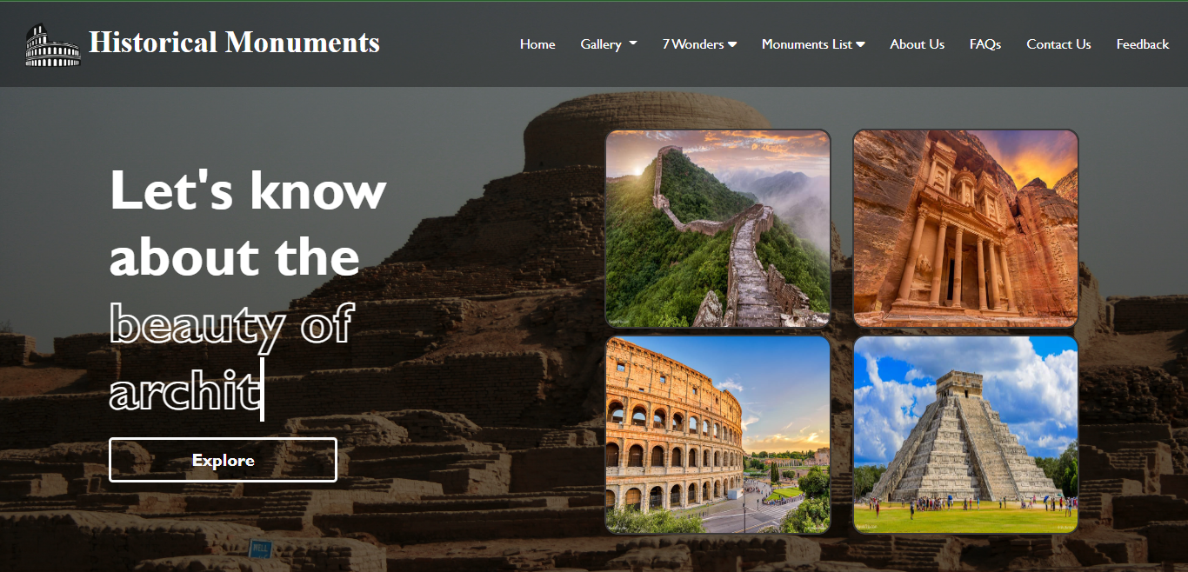

*­*

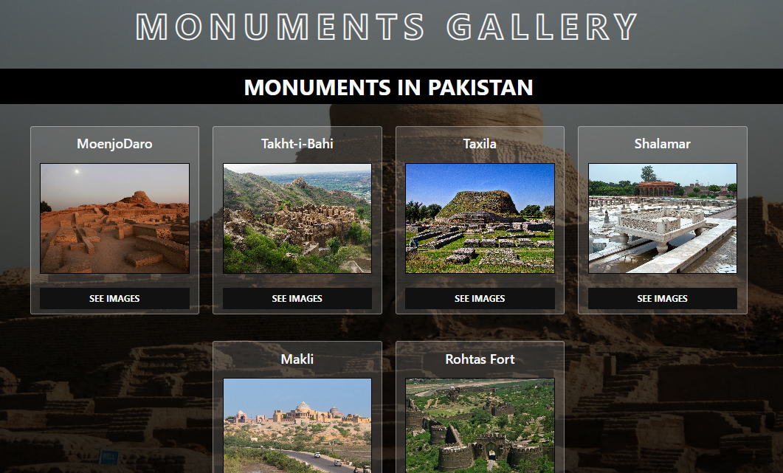*GALLERY*

*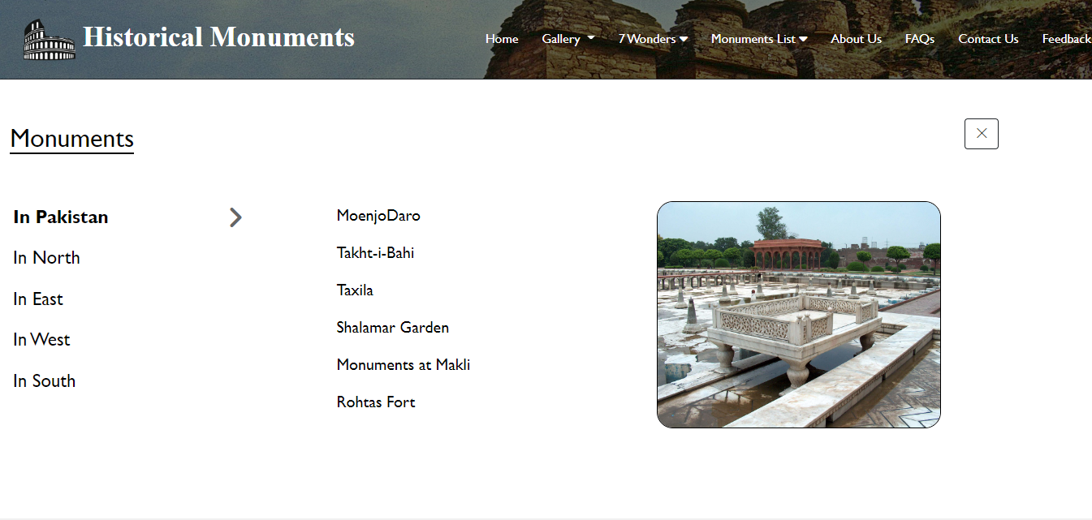NAVBAR*

*DROPDOWN*

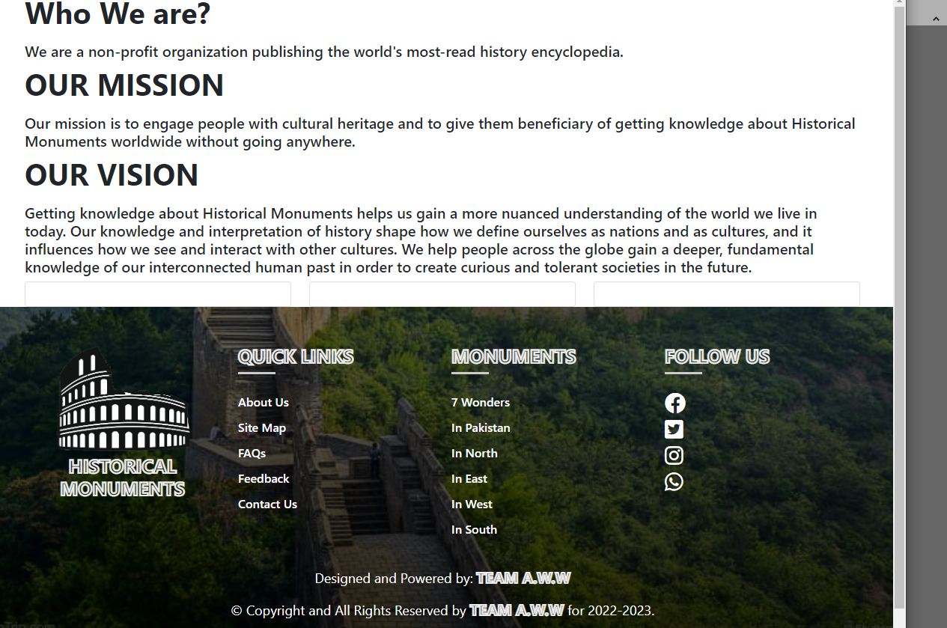*ABOUT US*

*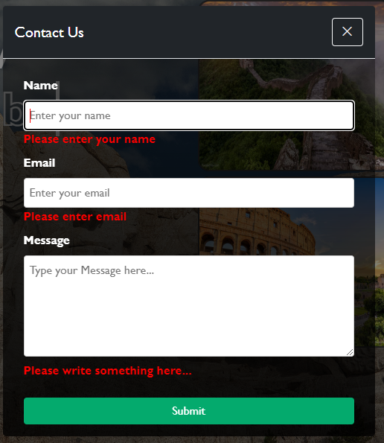CONTACT US:*

*FEEDBACK FORM*

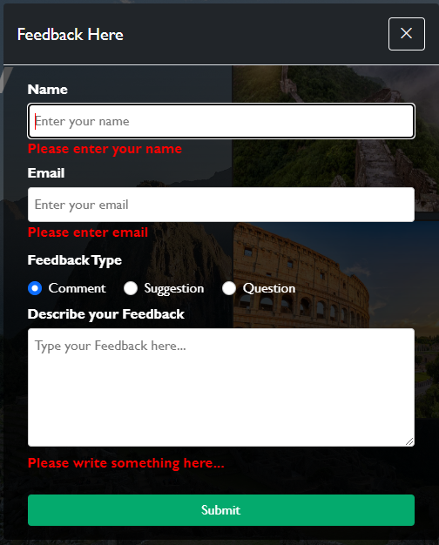

*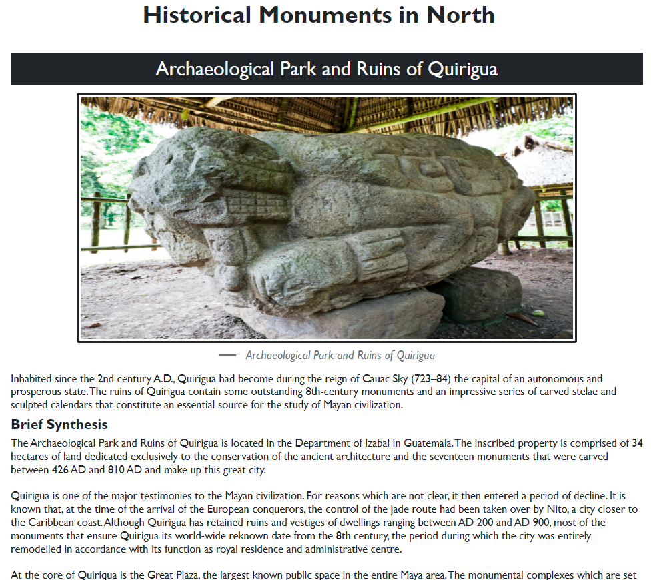MONUMENTS IN NORTH*

*FOOTER*

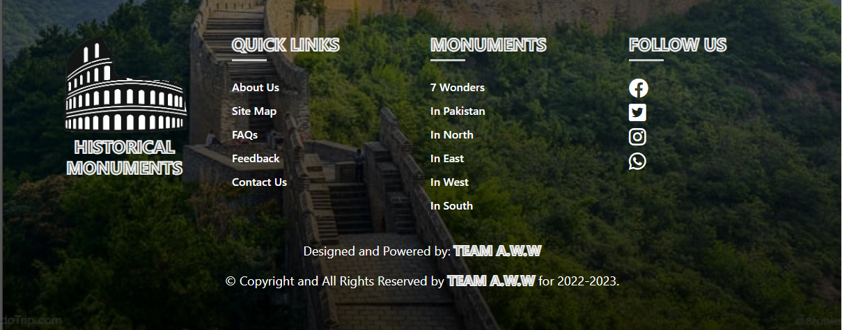

# ***Developer’s Guide***

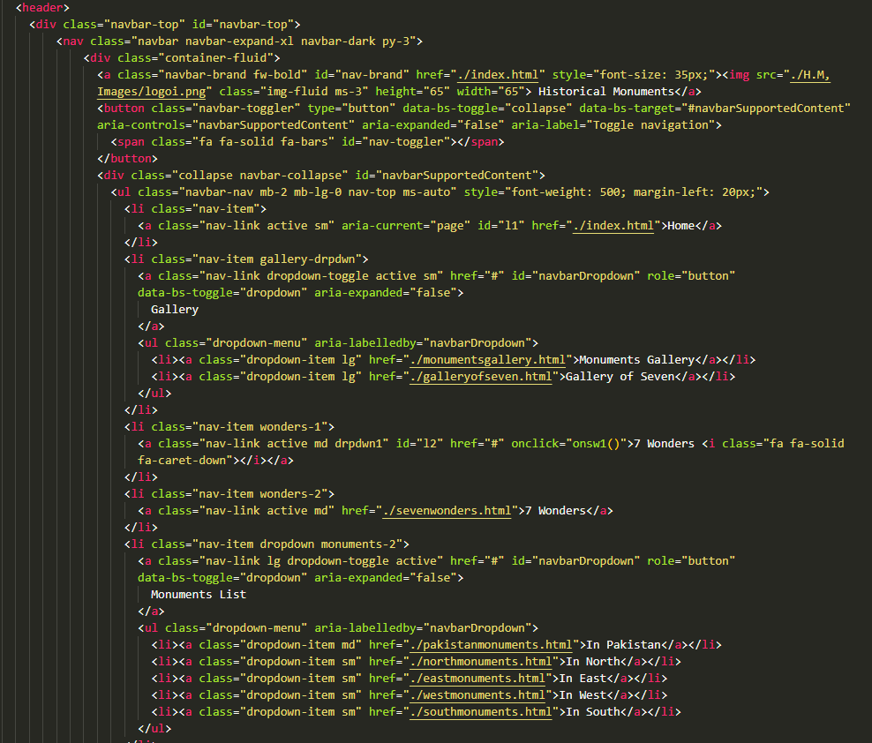***HOME***

*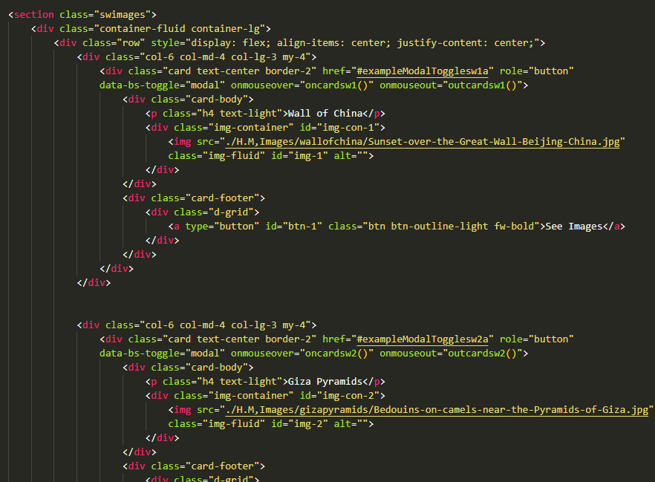****GALLERY OF SEVEN***

***MONUMENTS LIST***

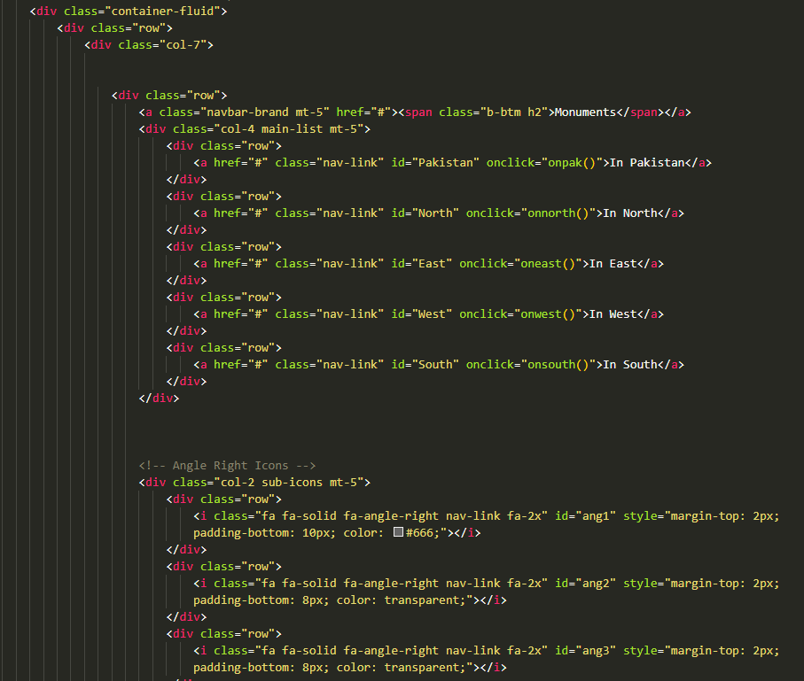

***Task Sheet***

|  |  |  |  |  |
| --- | --- | --- | --- | --- |
| Project Ref. No. | | Project Title | Date of Preparation of Activity Plan | |
| Sr. No. | Task | **HISTORICAL MONUMENTS** | Actual Days | Status |
| 1 | Analysis | 5 | OK |
| 2 | Design | 4 | OK |
| 3 | Development | 6 | OK |
| 4 | Testing | 2 | OK |
| 5 | Documentation | 2 | OK |